**Machine Learning and AI (AI-900) Lab Evidence PART 3**

**Lab 6** [**Analyze text in Azure AI Foundry portal**](https://msle.learnondemand.net/Lab/77496?instructionSetLang=en&classId=720986)

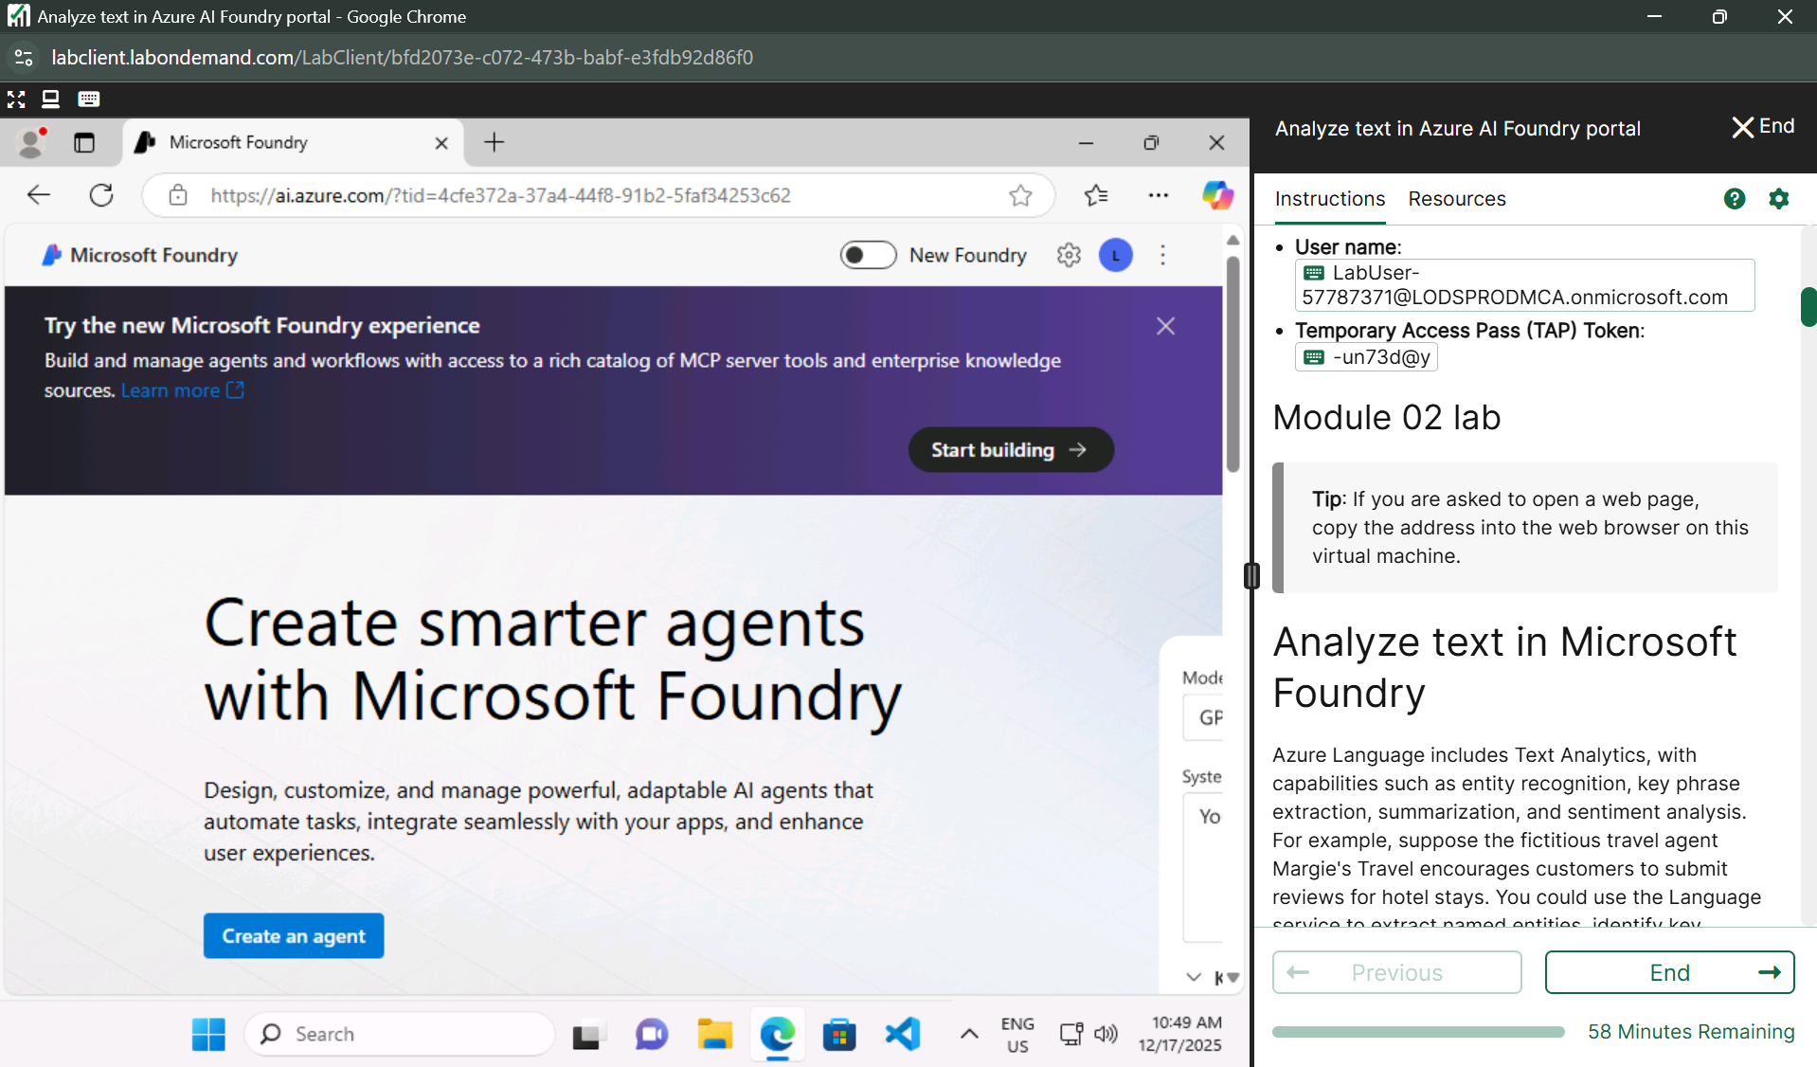



**Explore Azure AI Services**

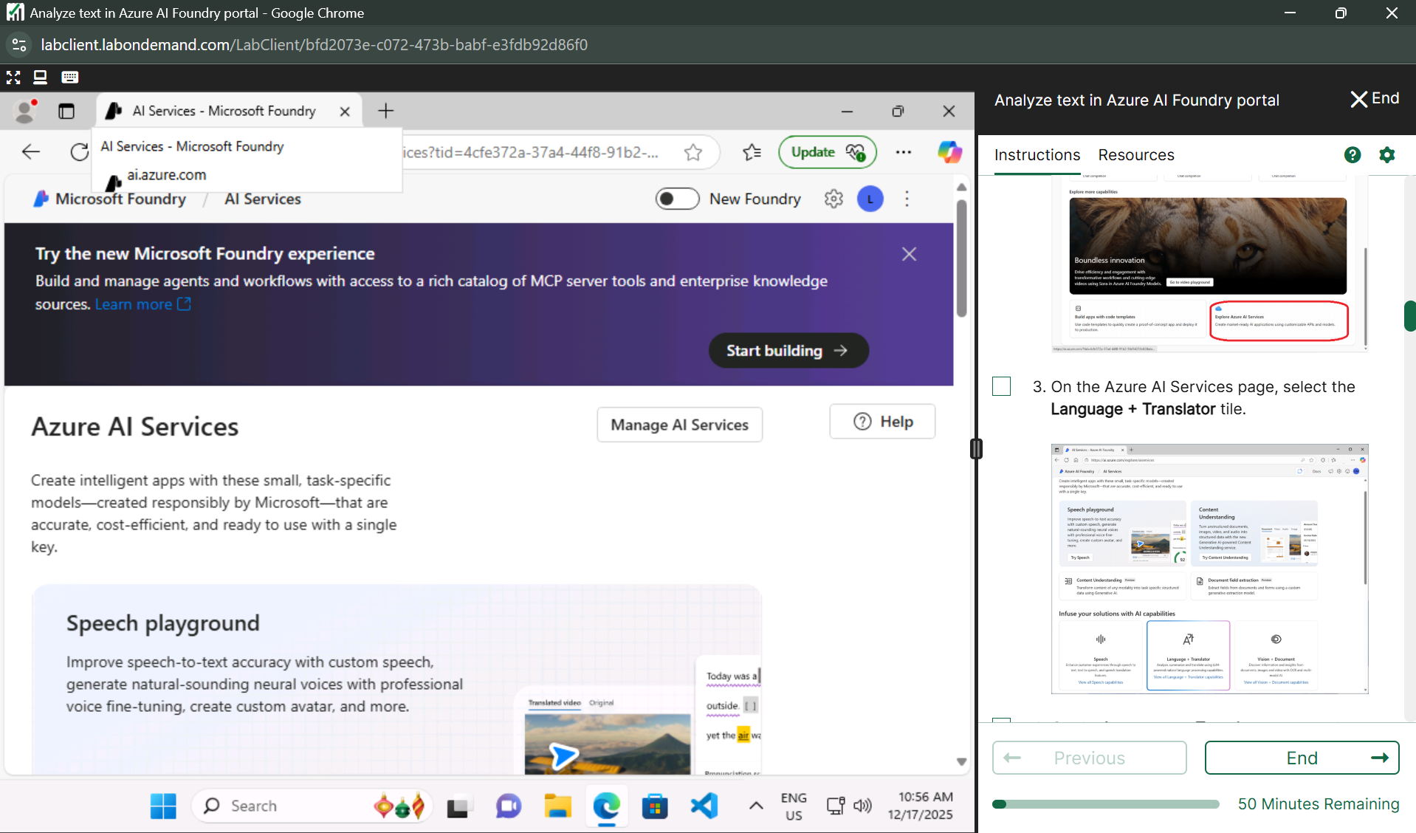

**Language and translator**

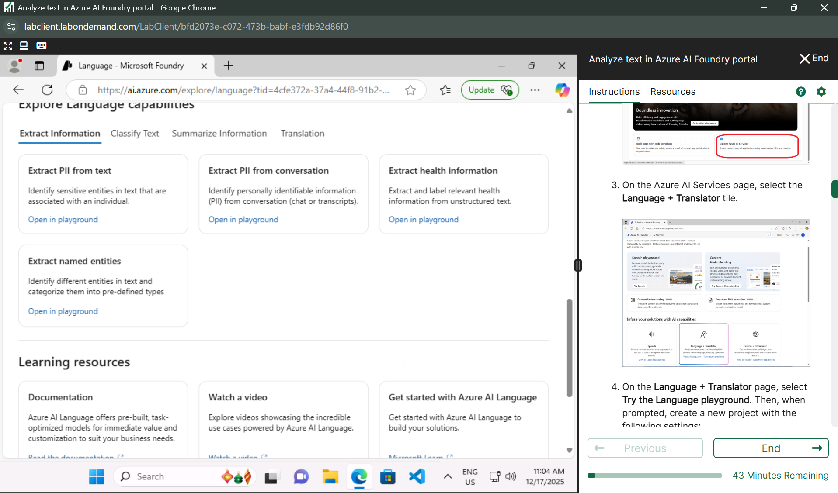

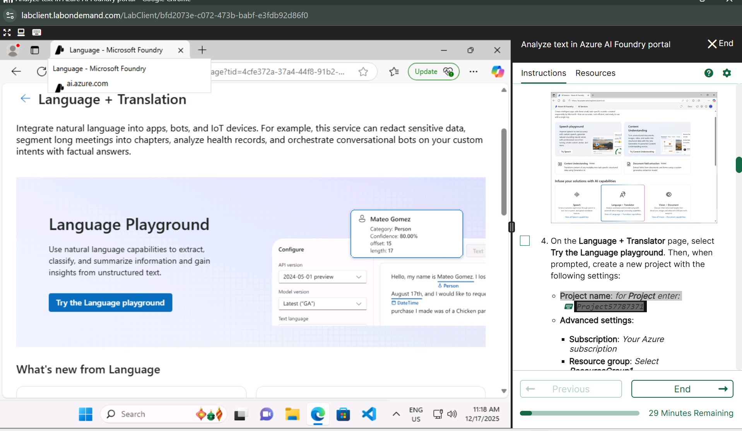

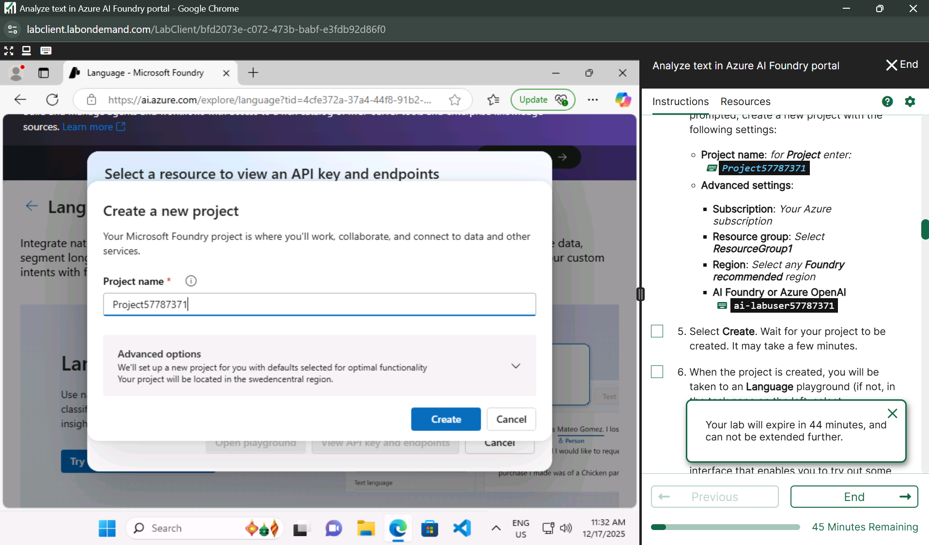

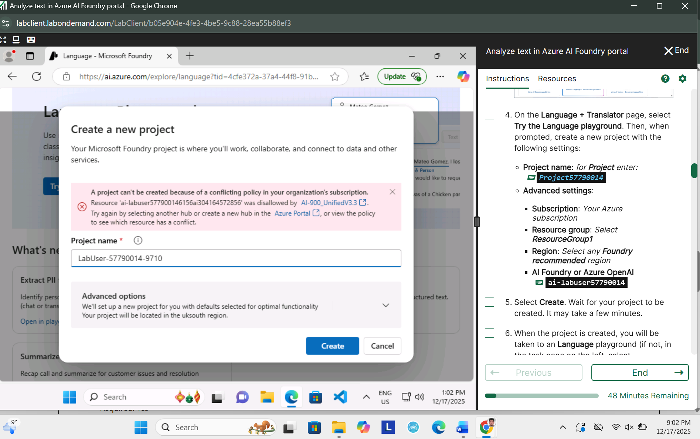

**Lab 6 subscription issue**

**Lab 7** [**Explore speech in Azure AI Foundry portal**](https://msle.learnondemand.net/Lab/77497?instructionSetLang=en&classId=720986)

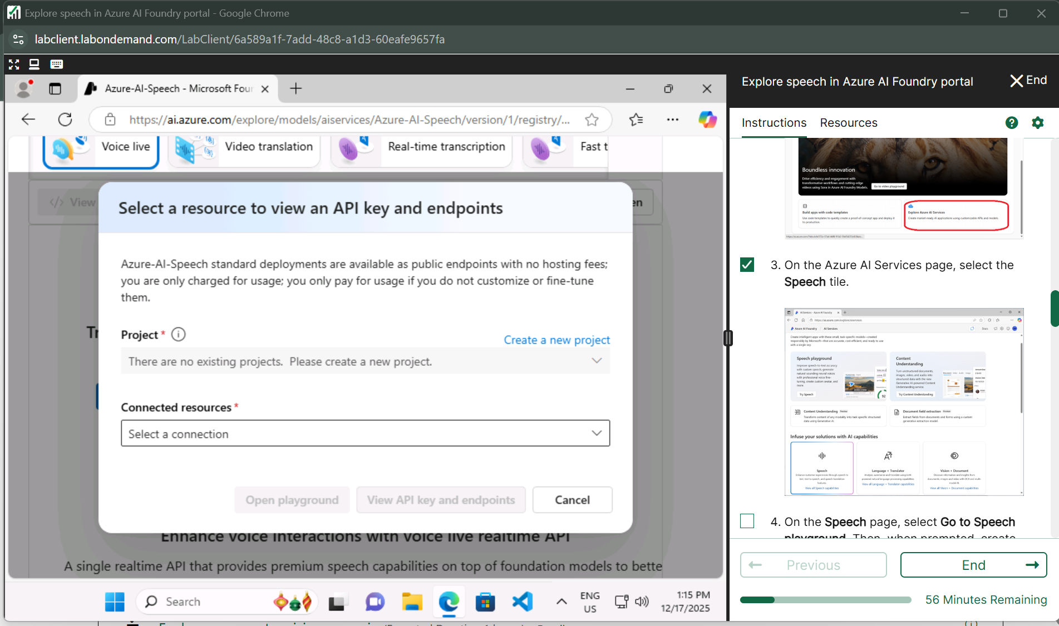

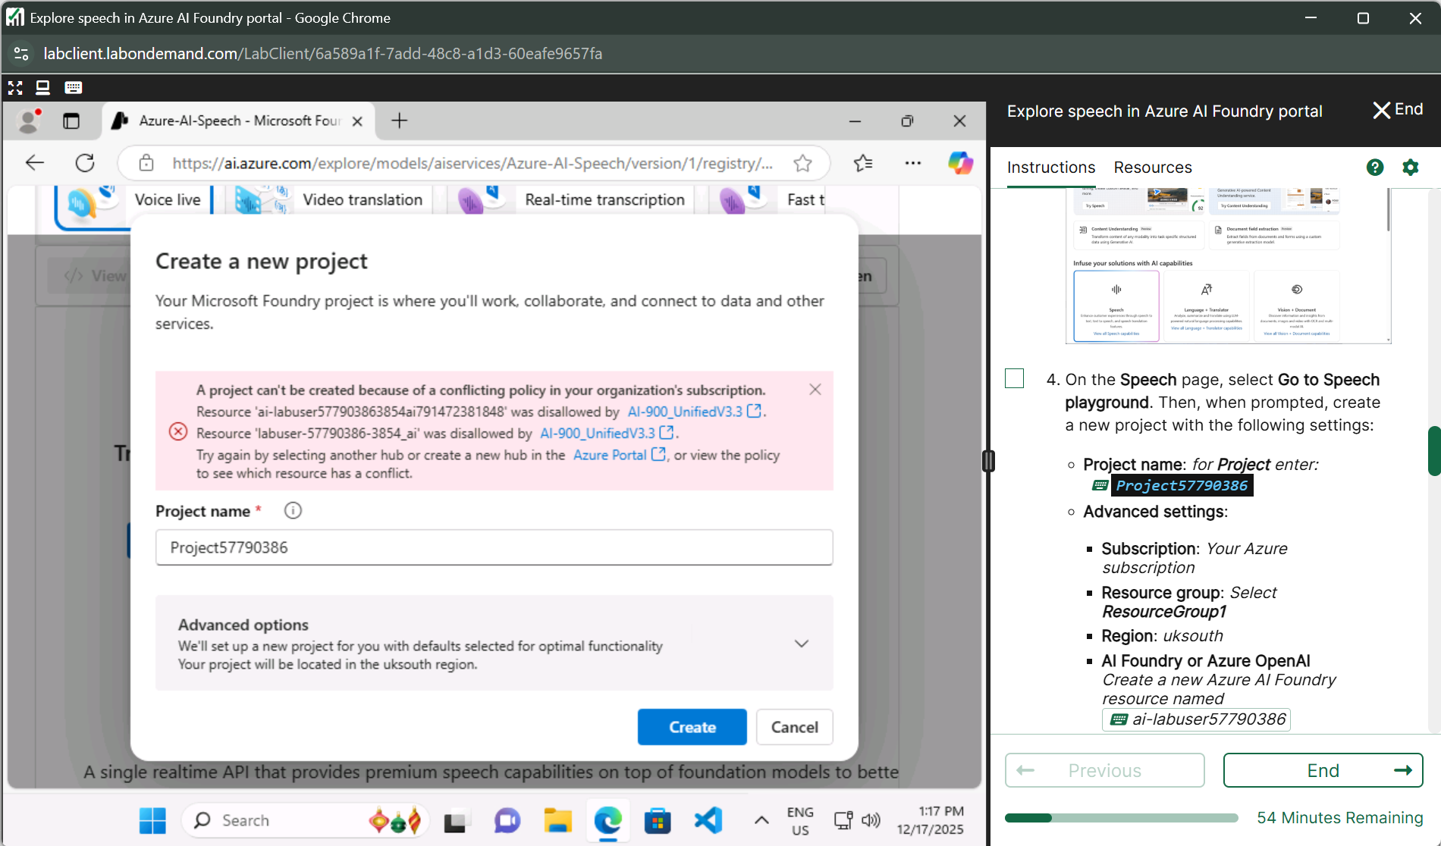

**Lab 7 subscription issue**

**Lab 8** [**Explore a computer vision scenario**](https://msle.learnondemand.net/Lab/77503?instructionSetLang=en&classId=720986)

**Photo Tagger**

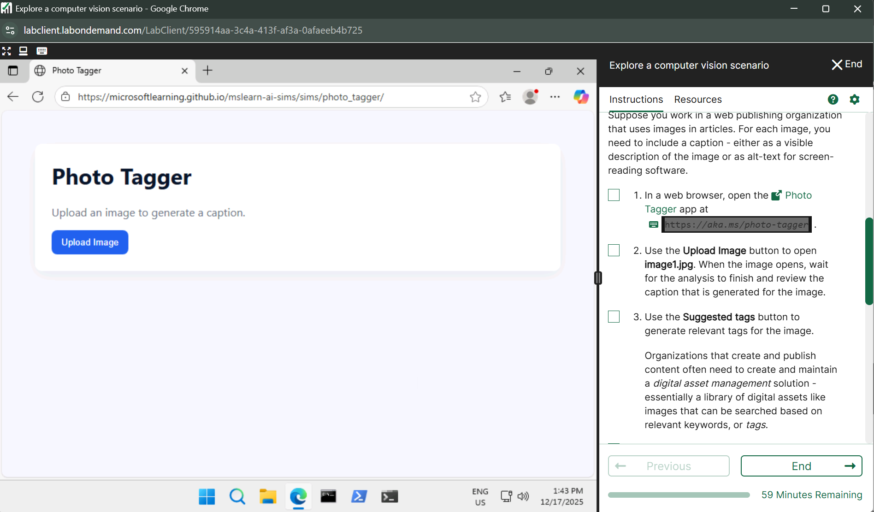

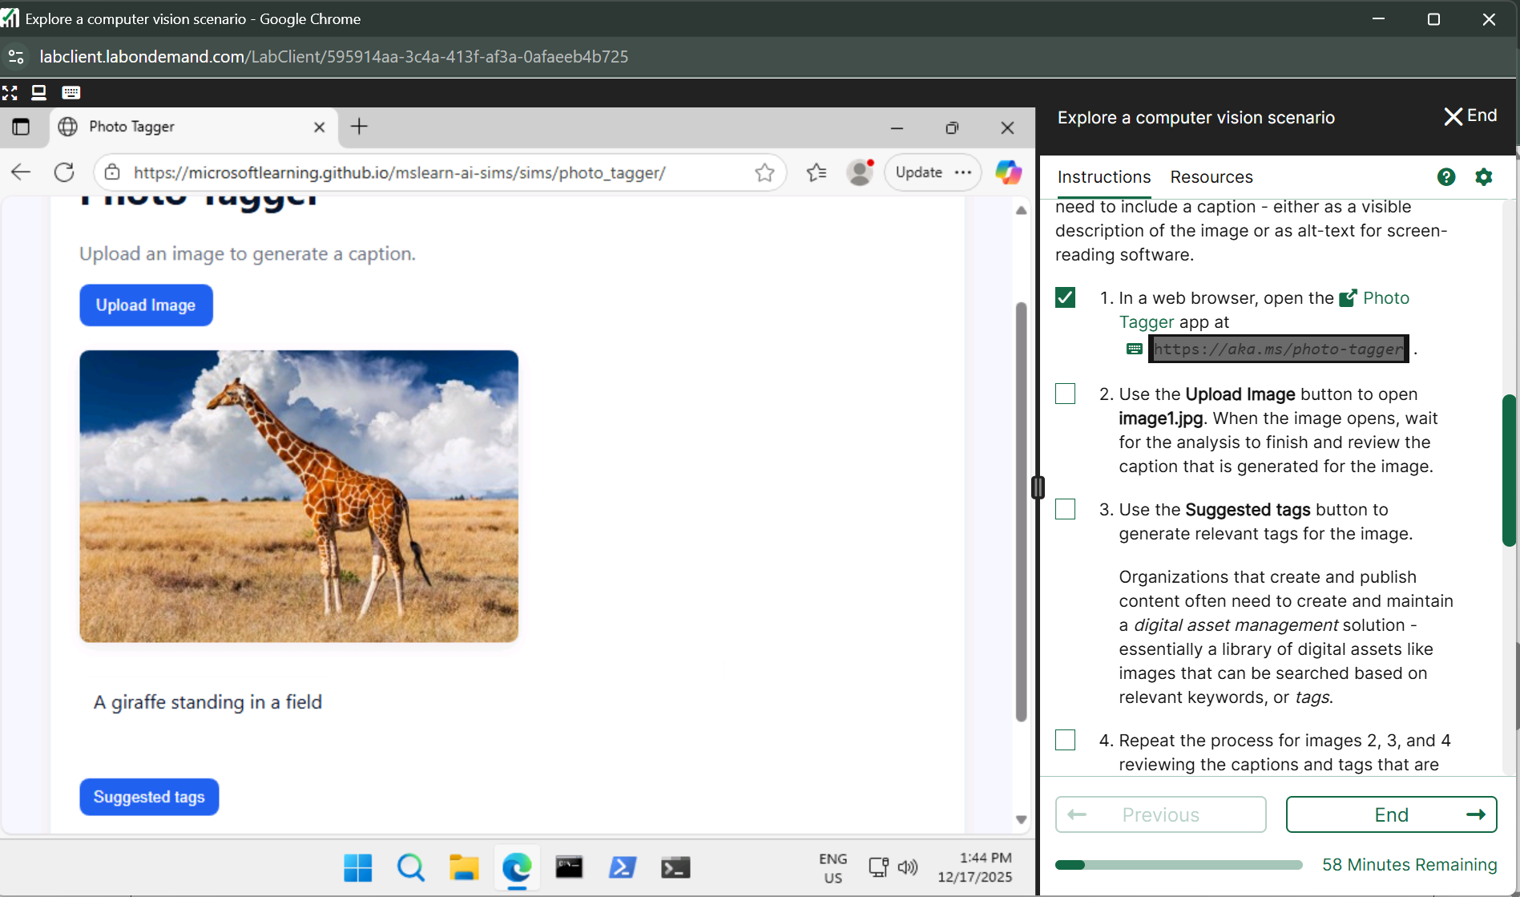

**Suggested tags**

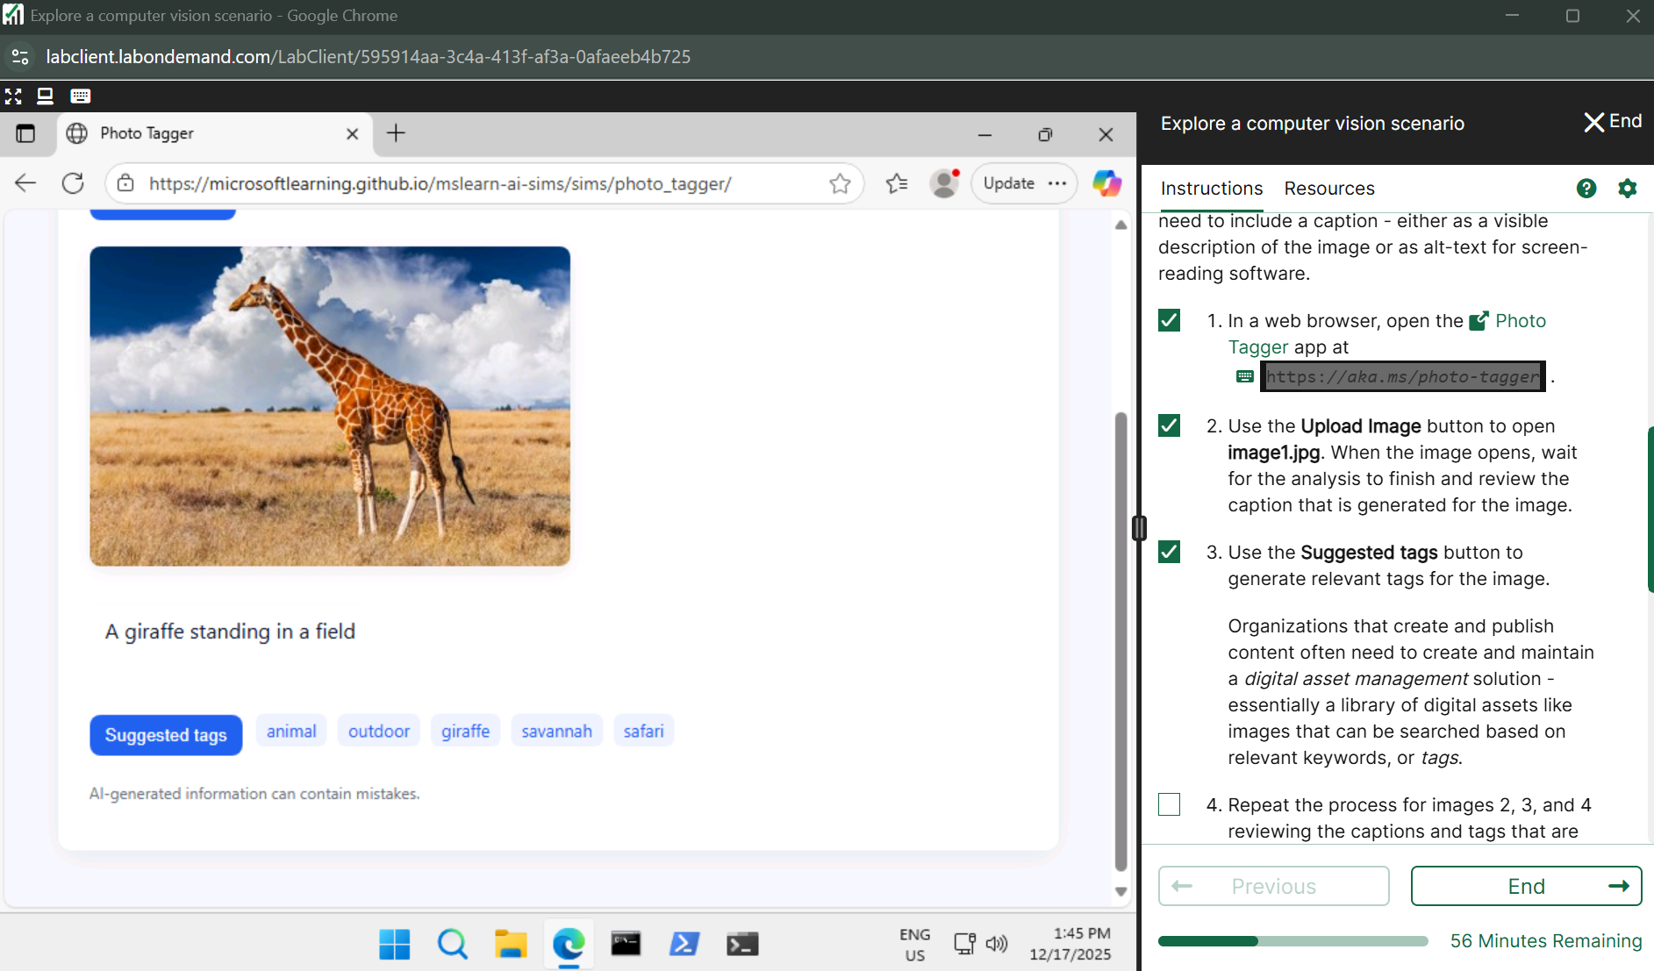

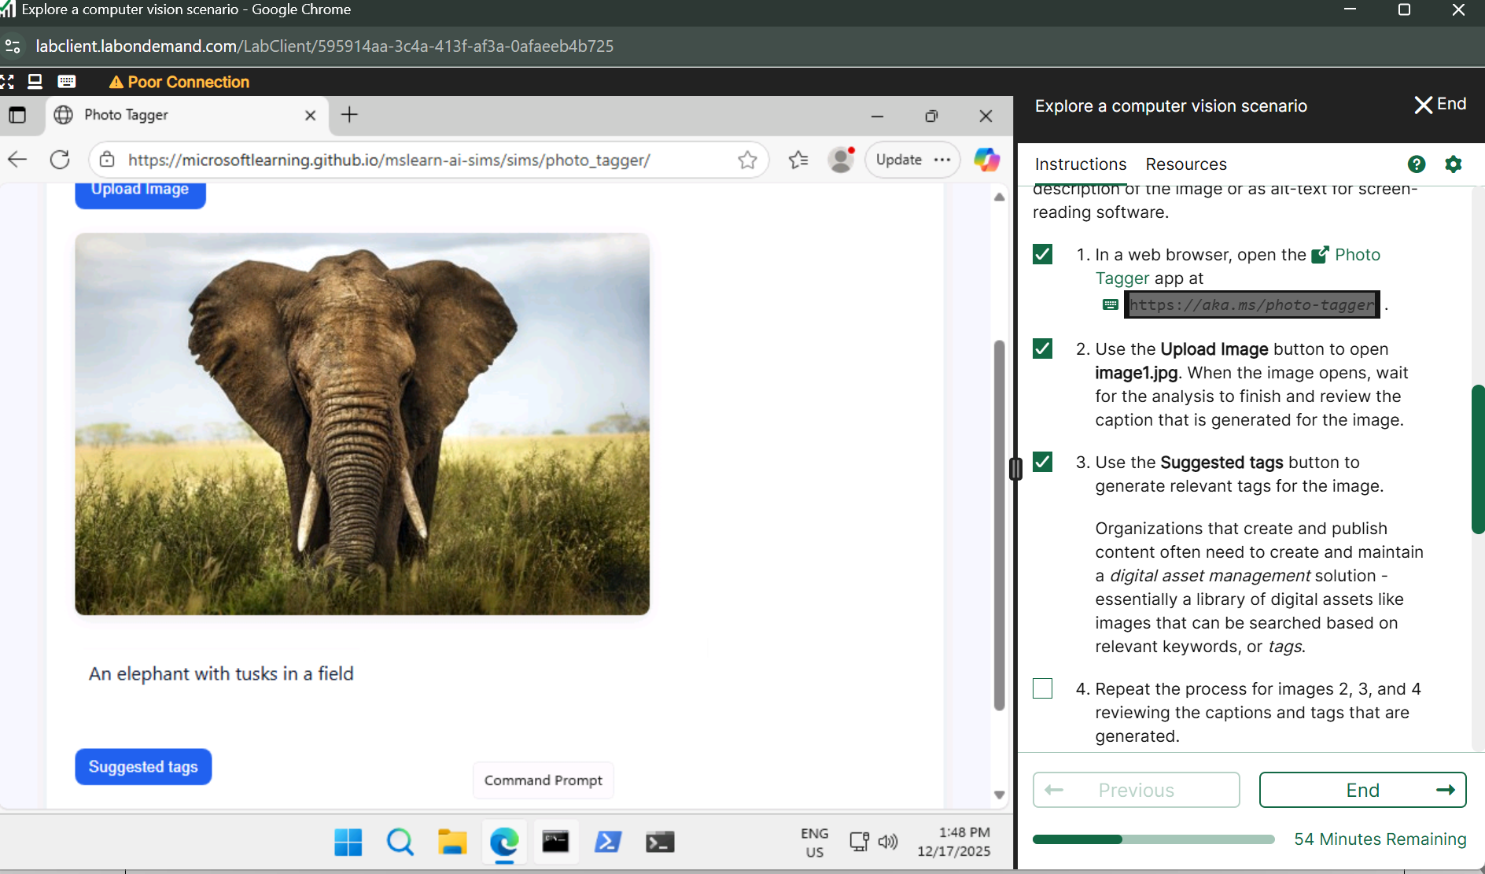

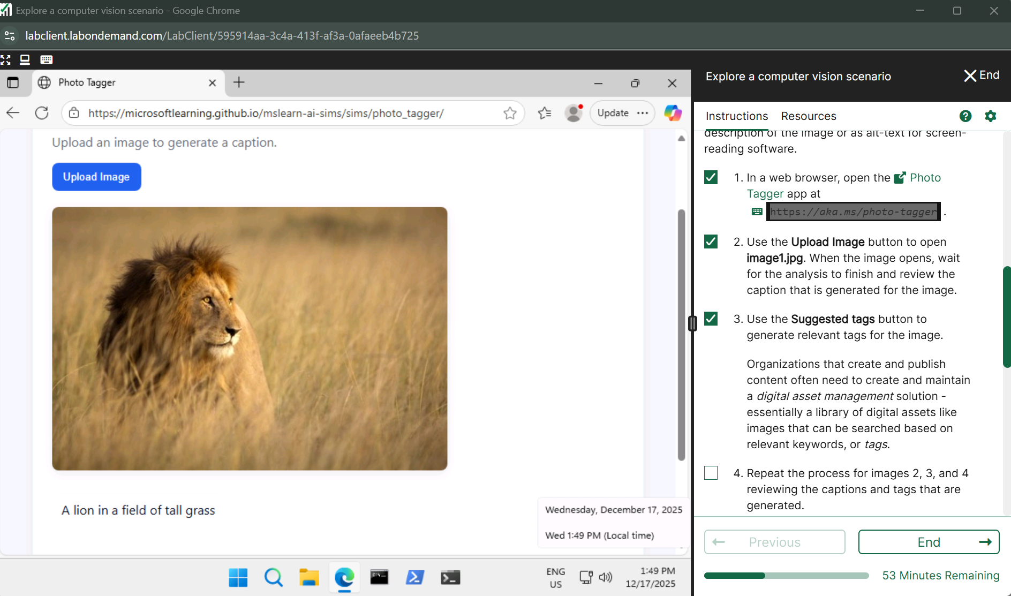

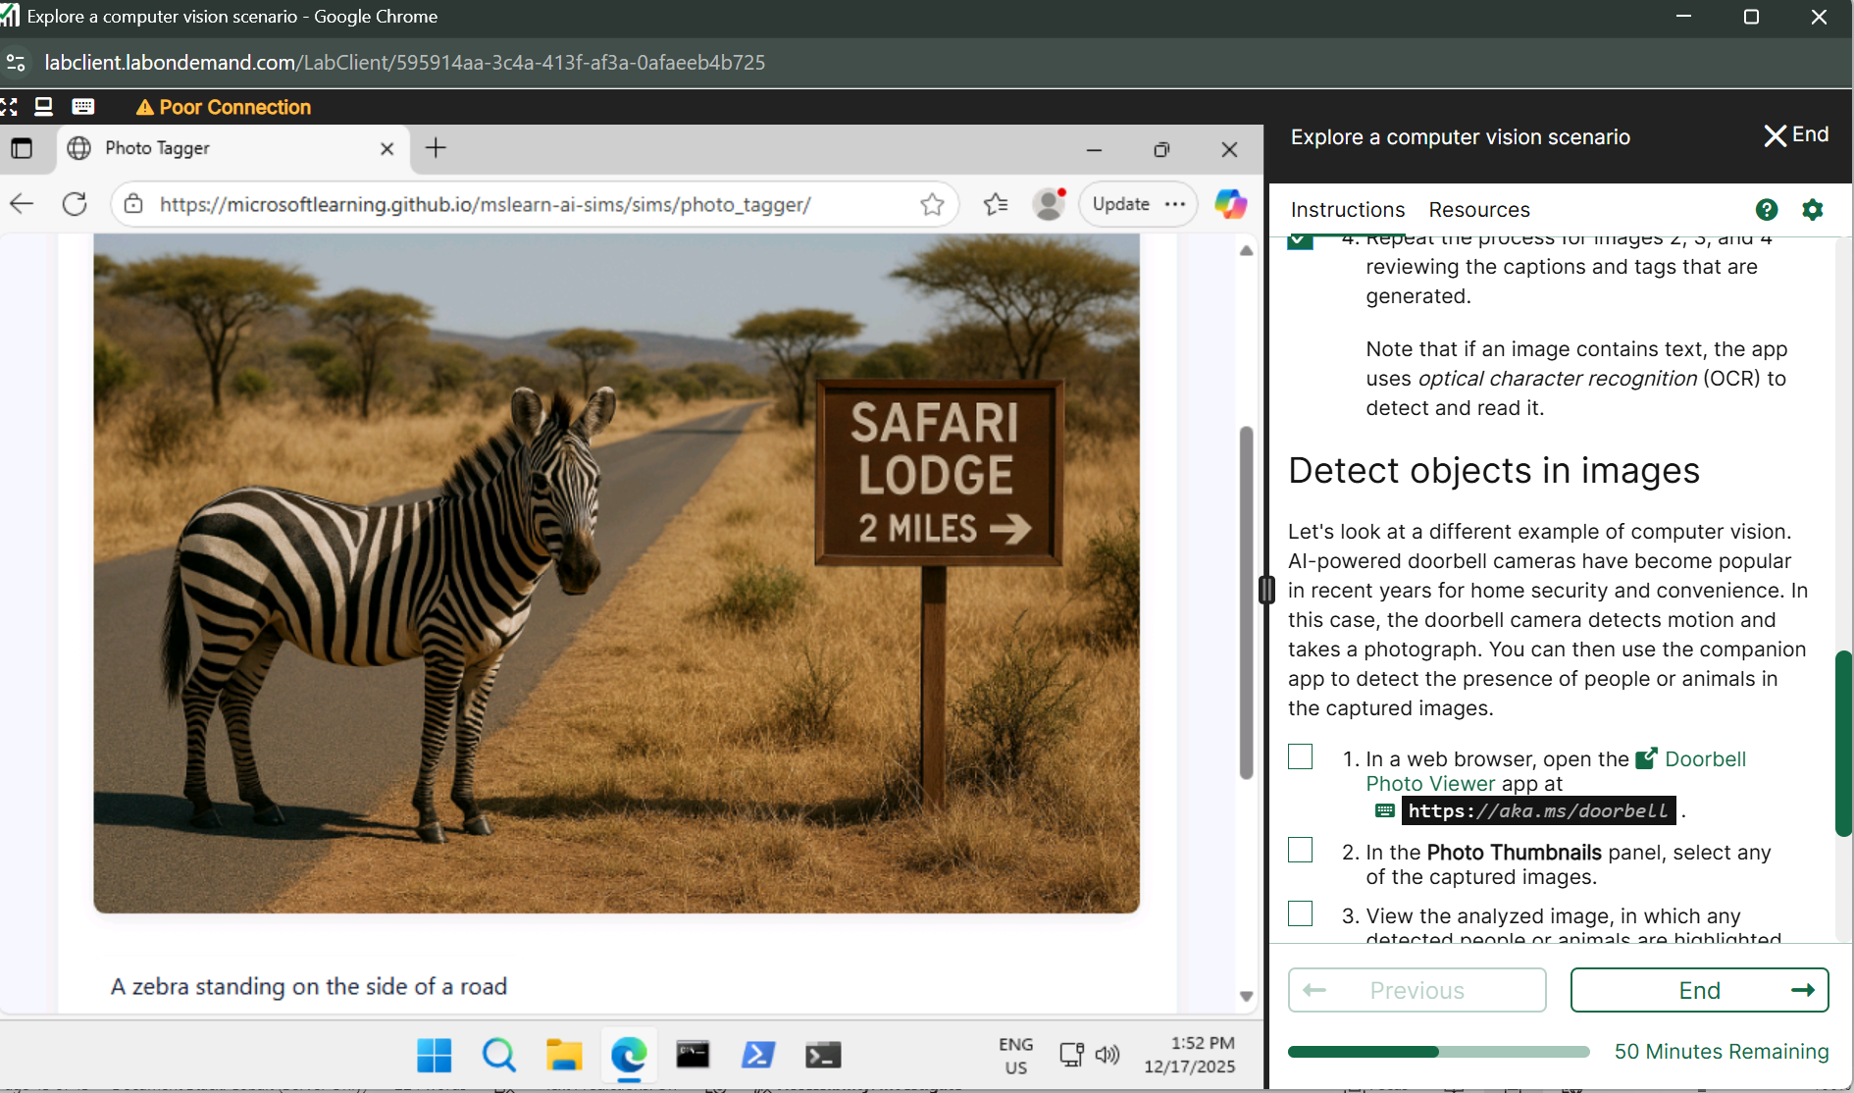

**Detect objects in images**

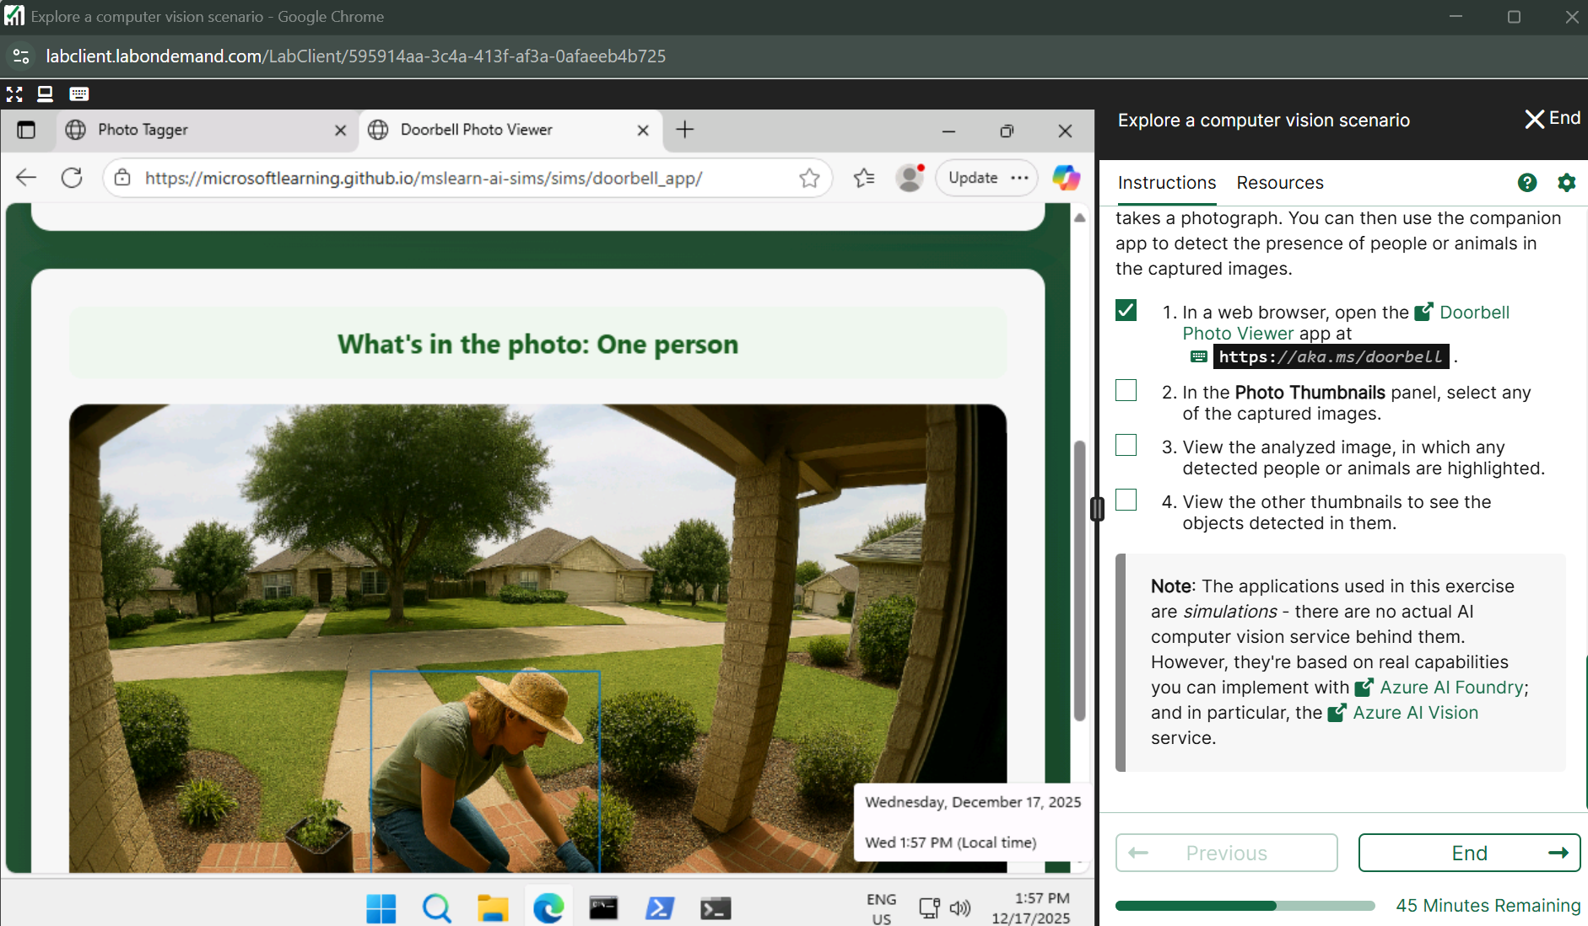

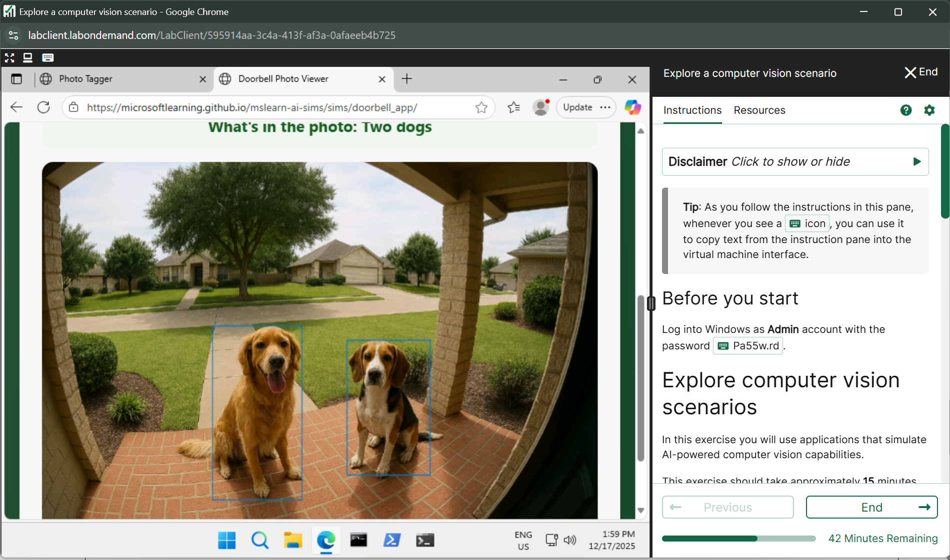

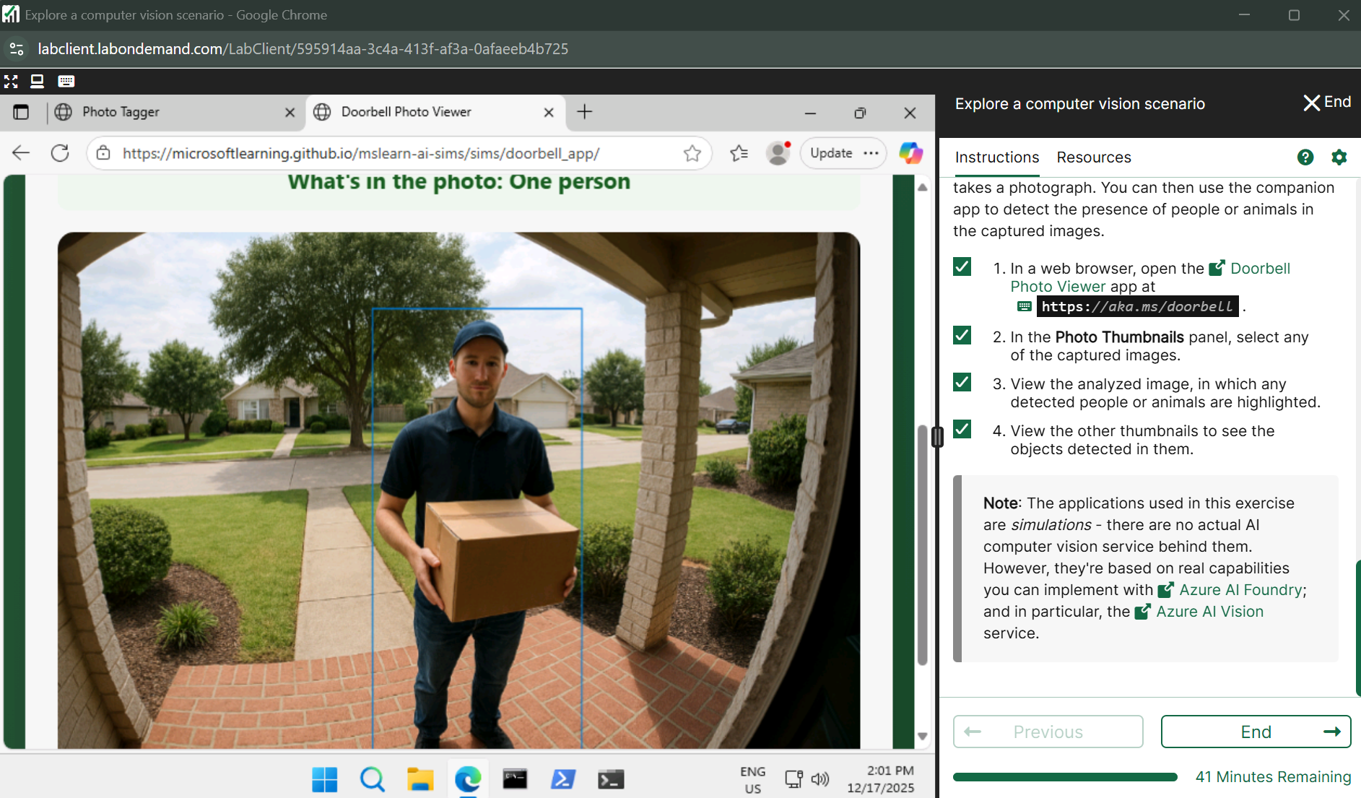

**Lab 9** [**Analyze images in Azure AI Foundry portal**](https://msle.learnondemand.net/Lab/77498?instructionSetLang=en&classId=720986)

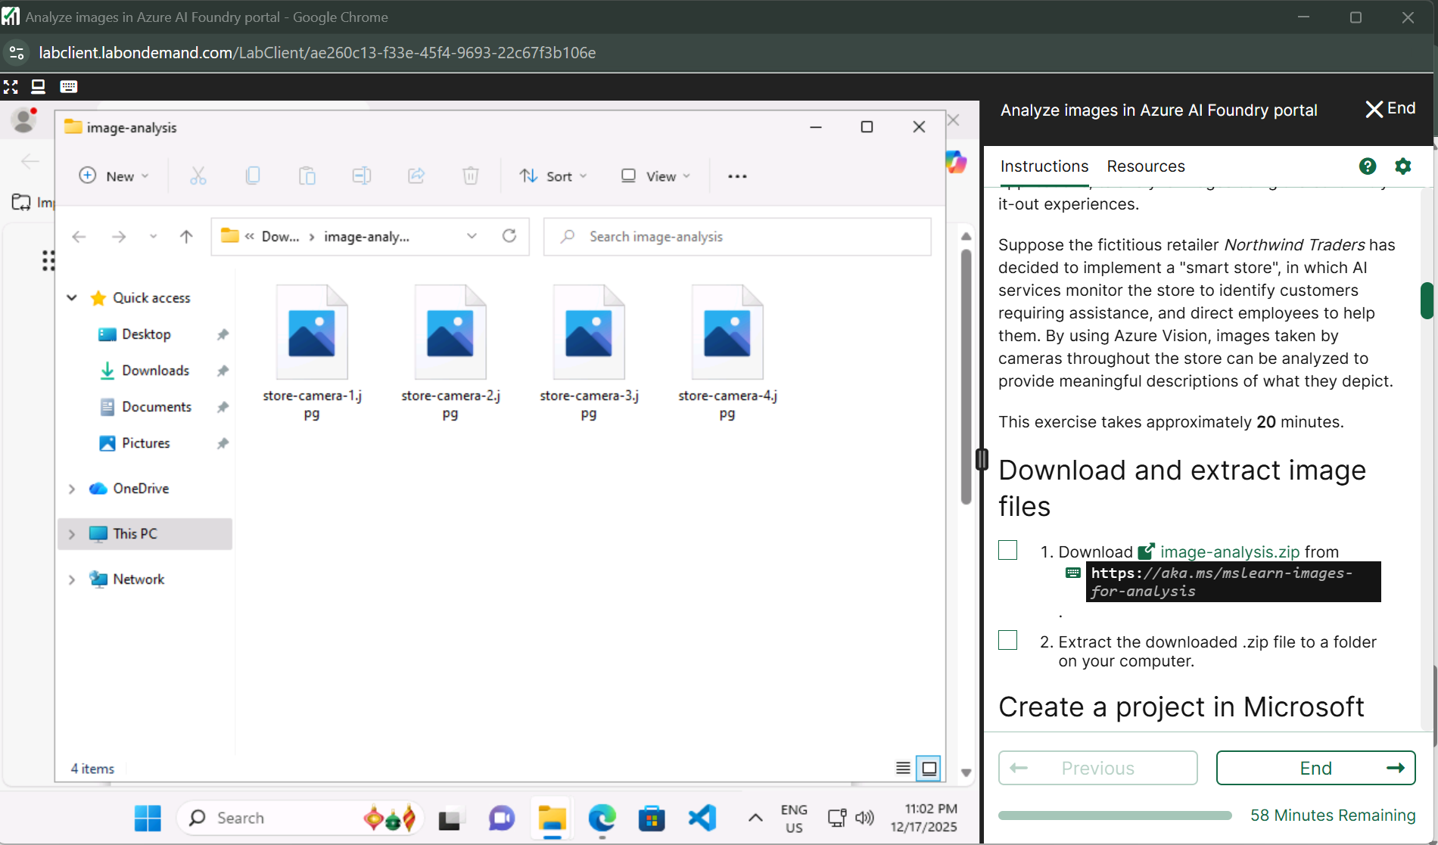

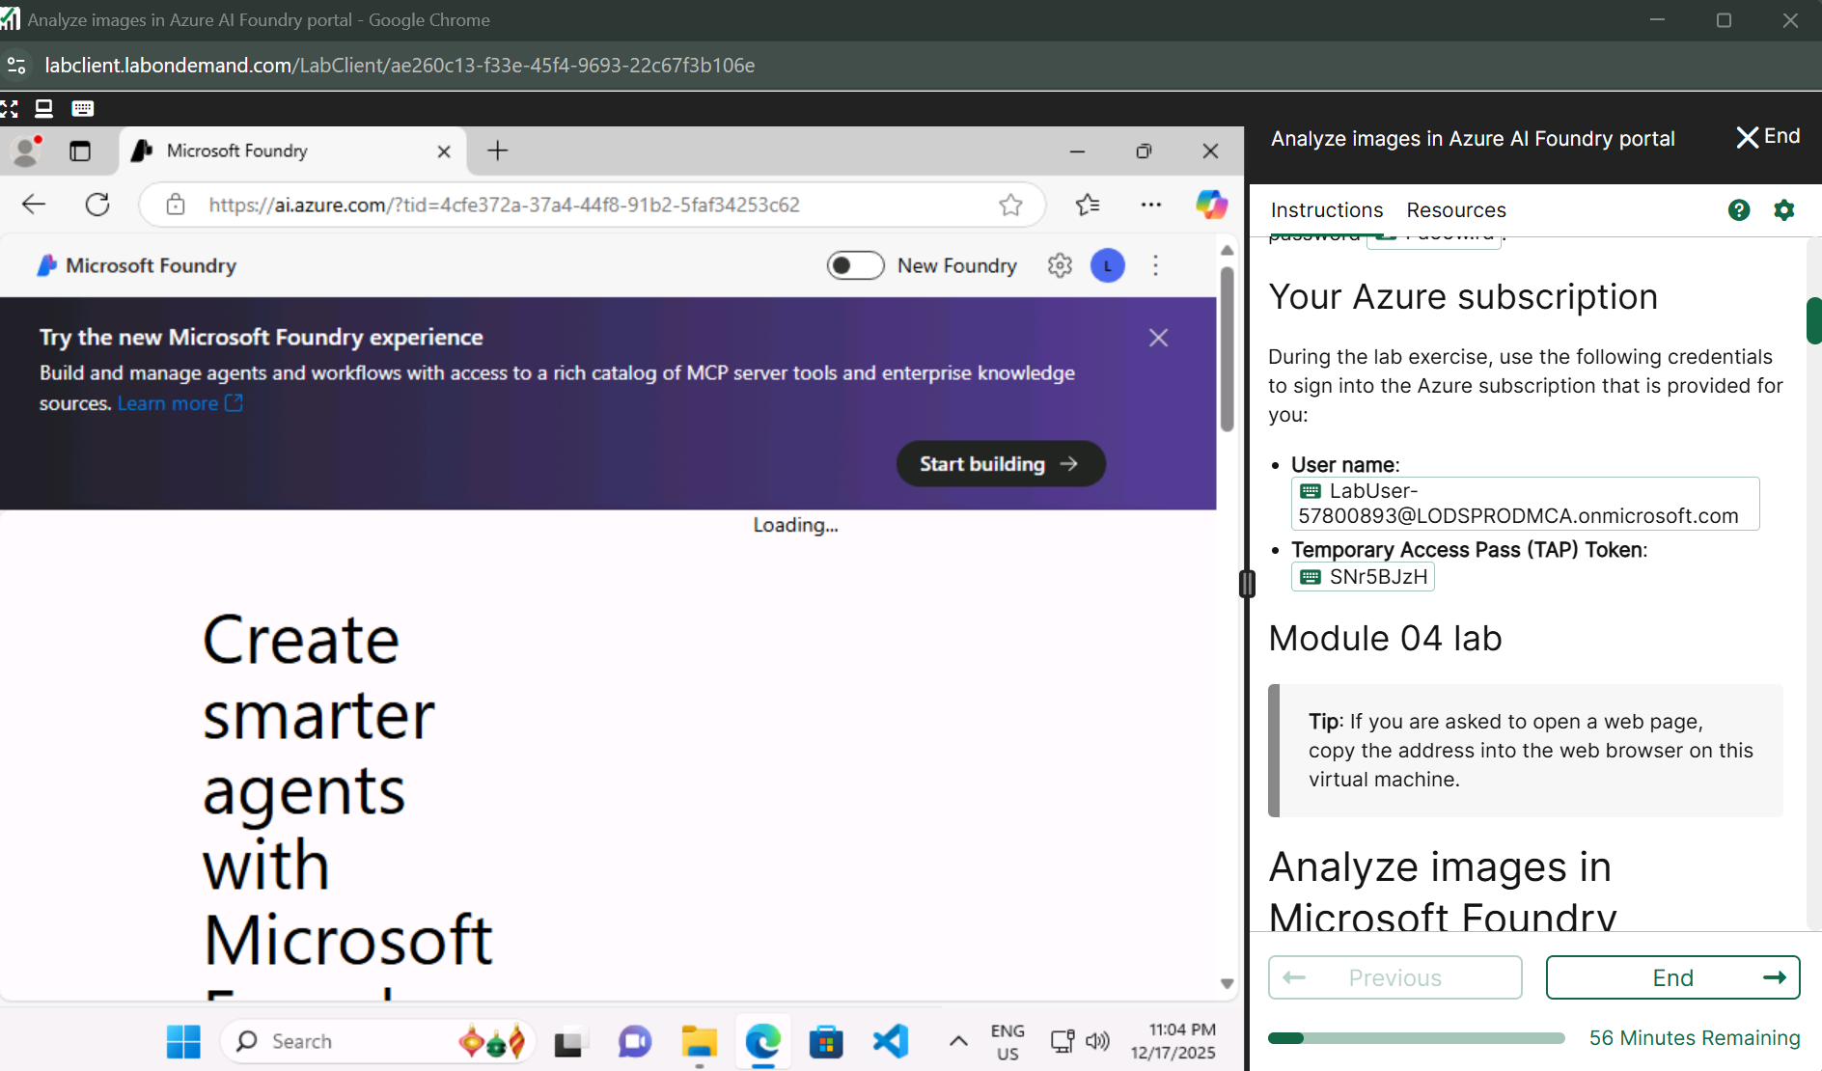

**Vision + Document page**

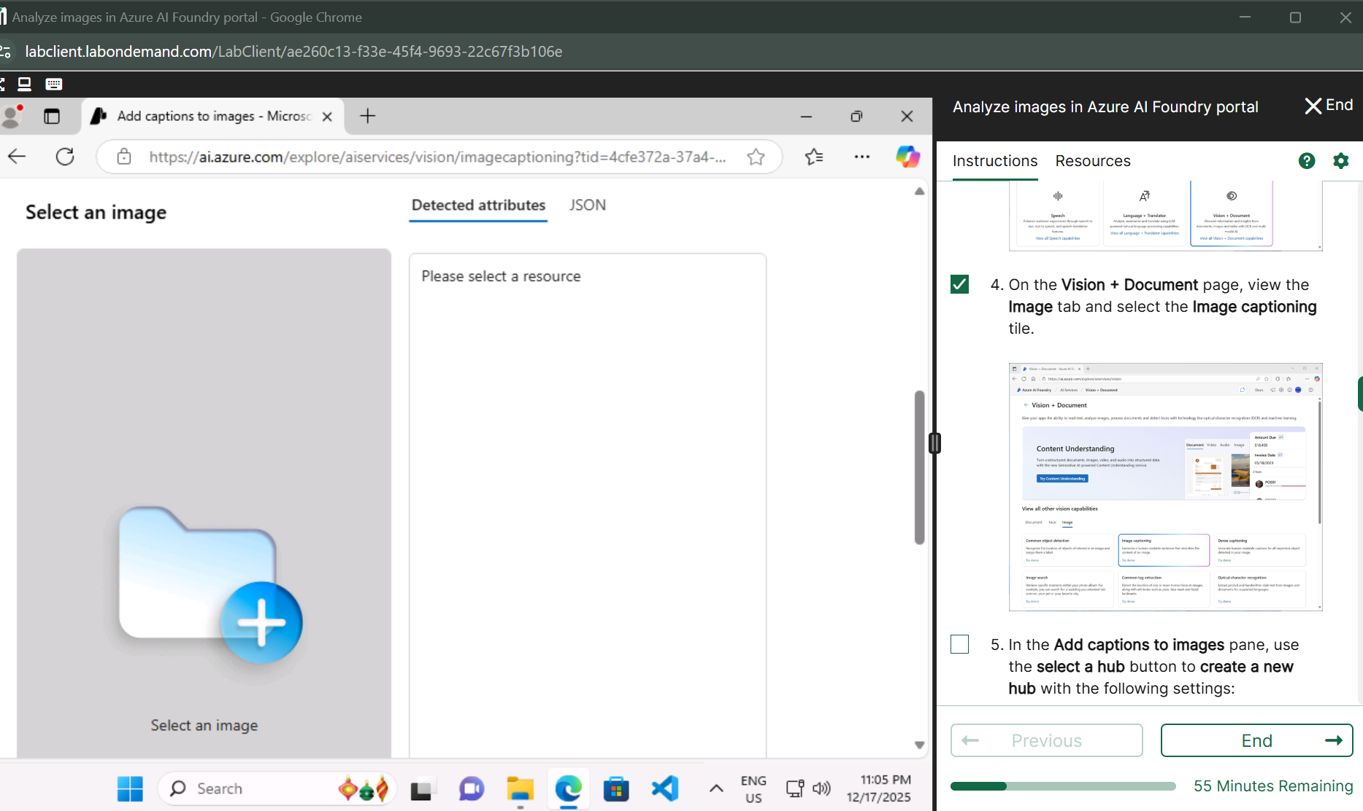

**Create a new hub**

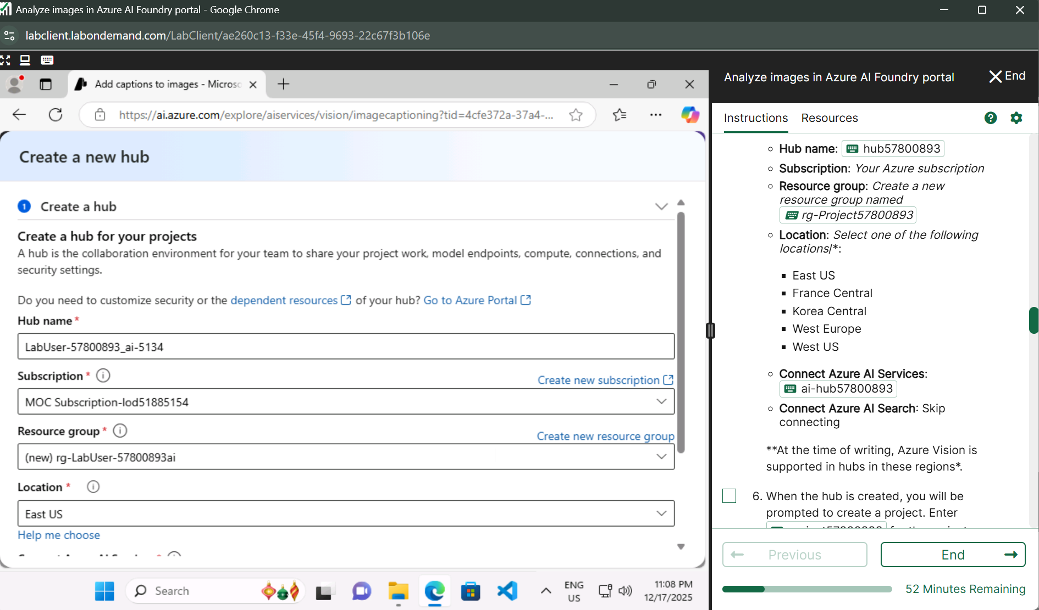

**Create a new hub**

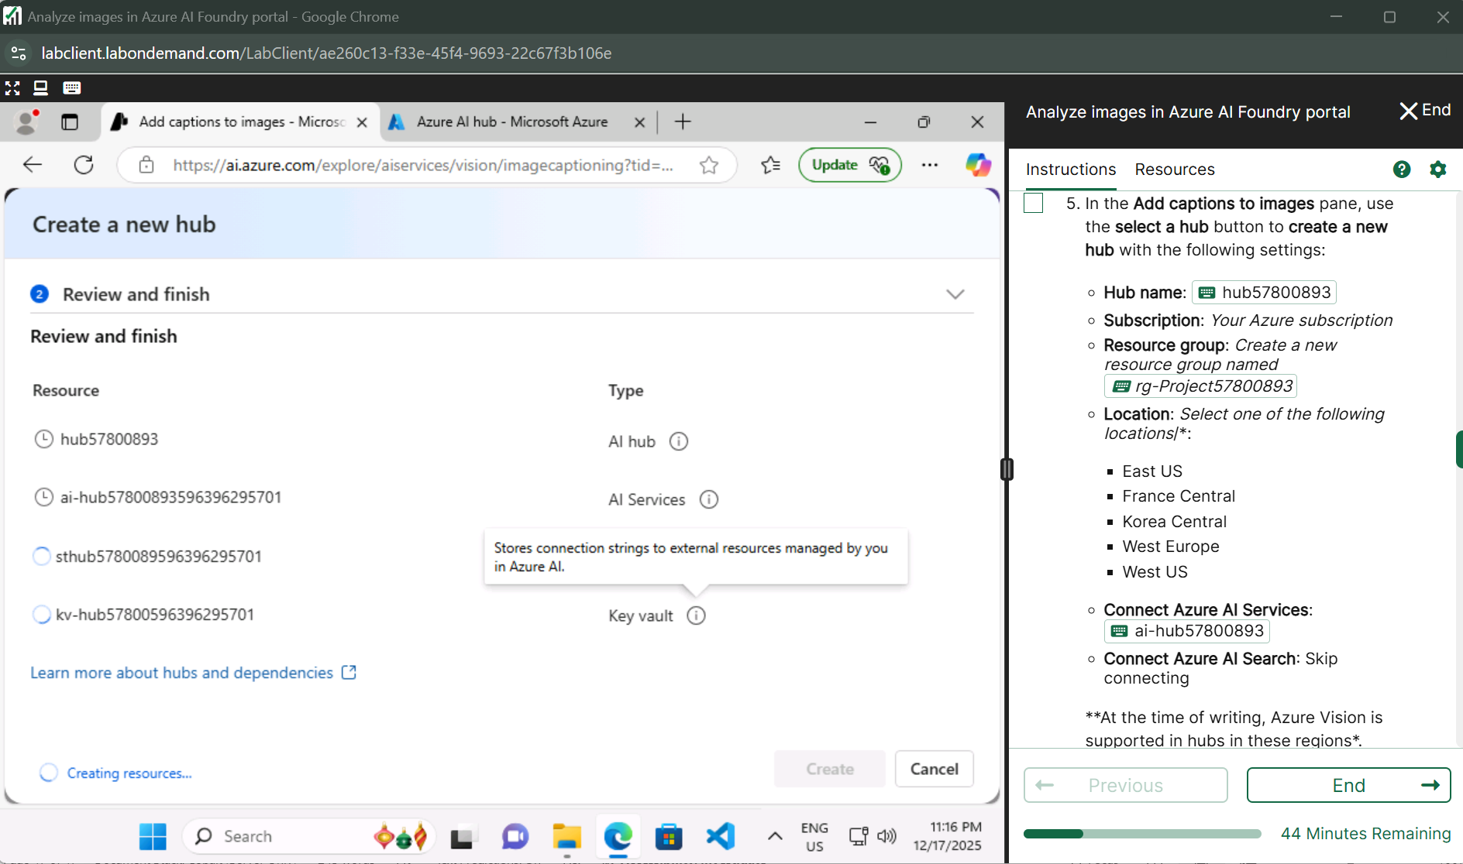

**Create a Project**

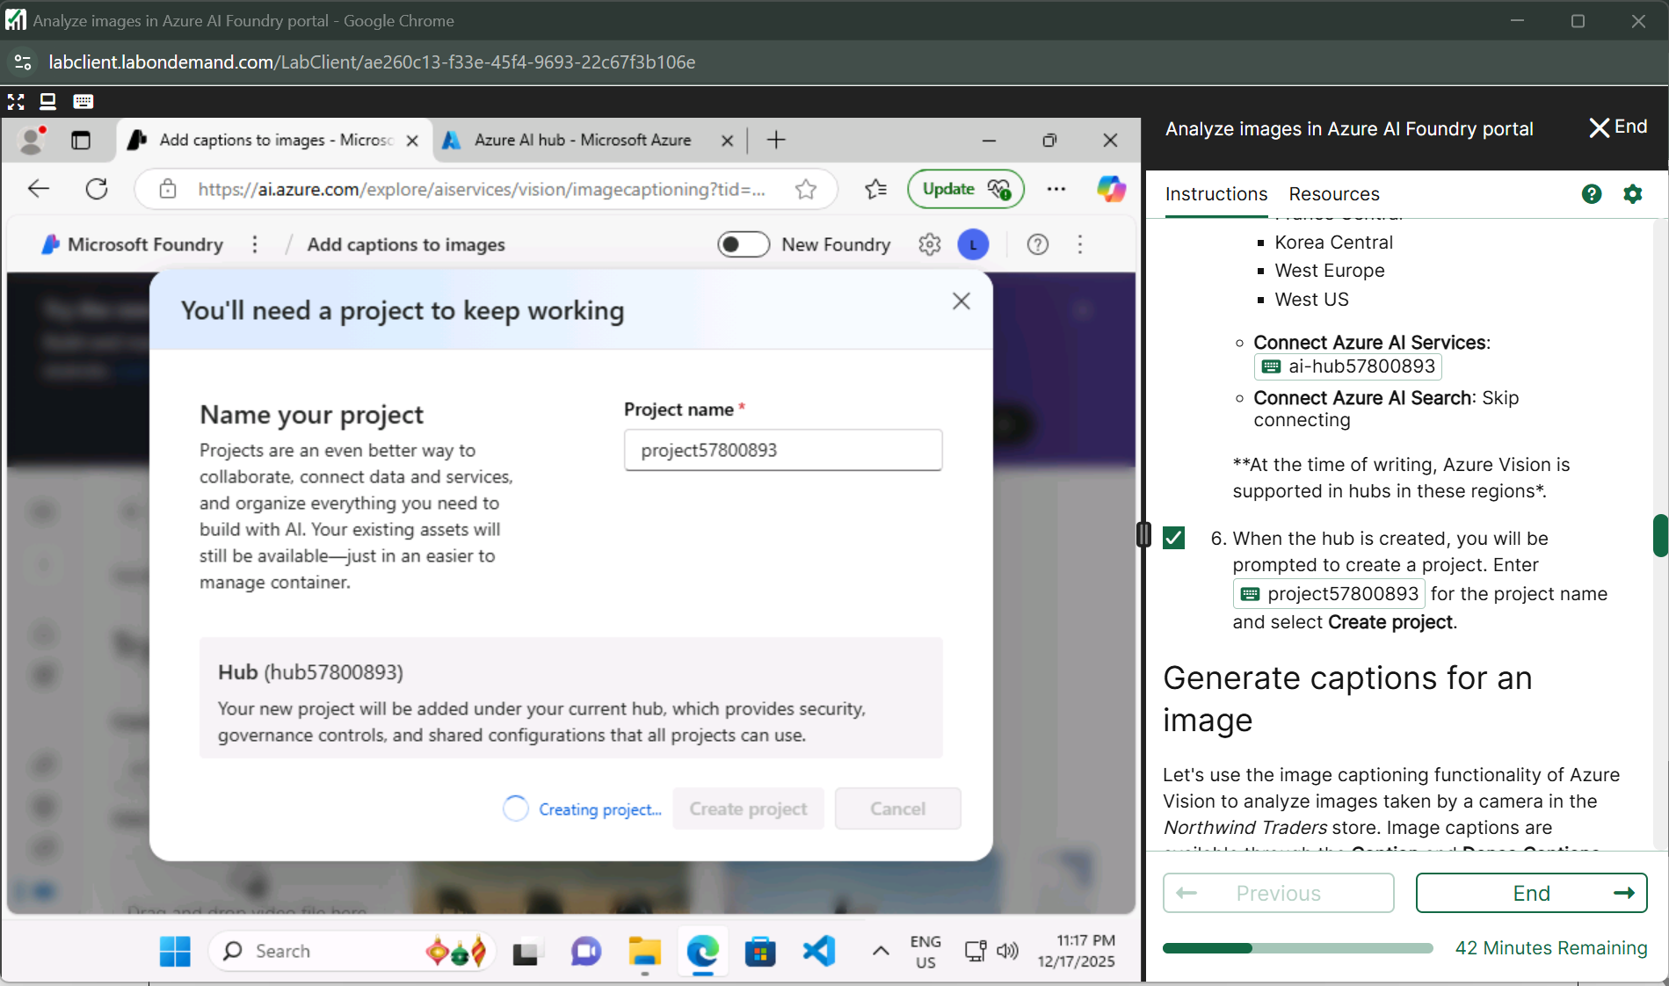

**When I created a new hub they was like subscription issue after that I use the azure portal but as I go to Ai services but and this page not giving me access of vision document and be like u need subscription for it**

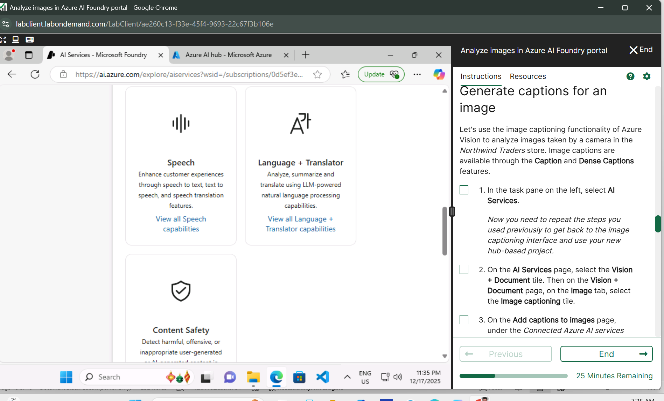

**Lab 10** [**Explore an AI information extraction scenario**](https://msle.learnondemand.net/Lab/77504?instructionSetLang=en&classId=720986)

[**Receipt Analyzer**](https://aka.ms/receipt-analyzer)**app**

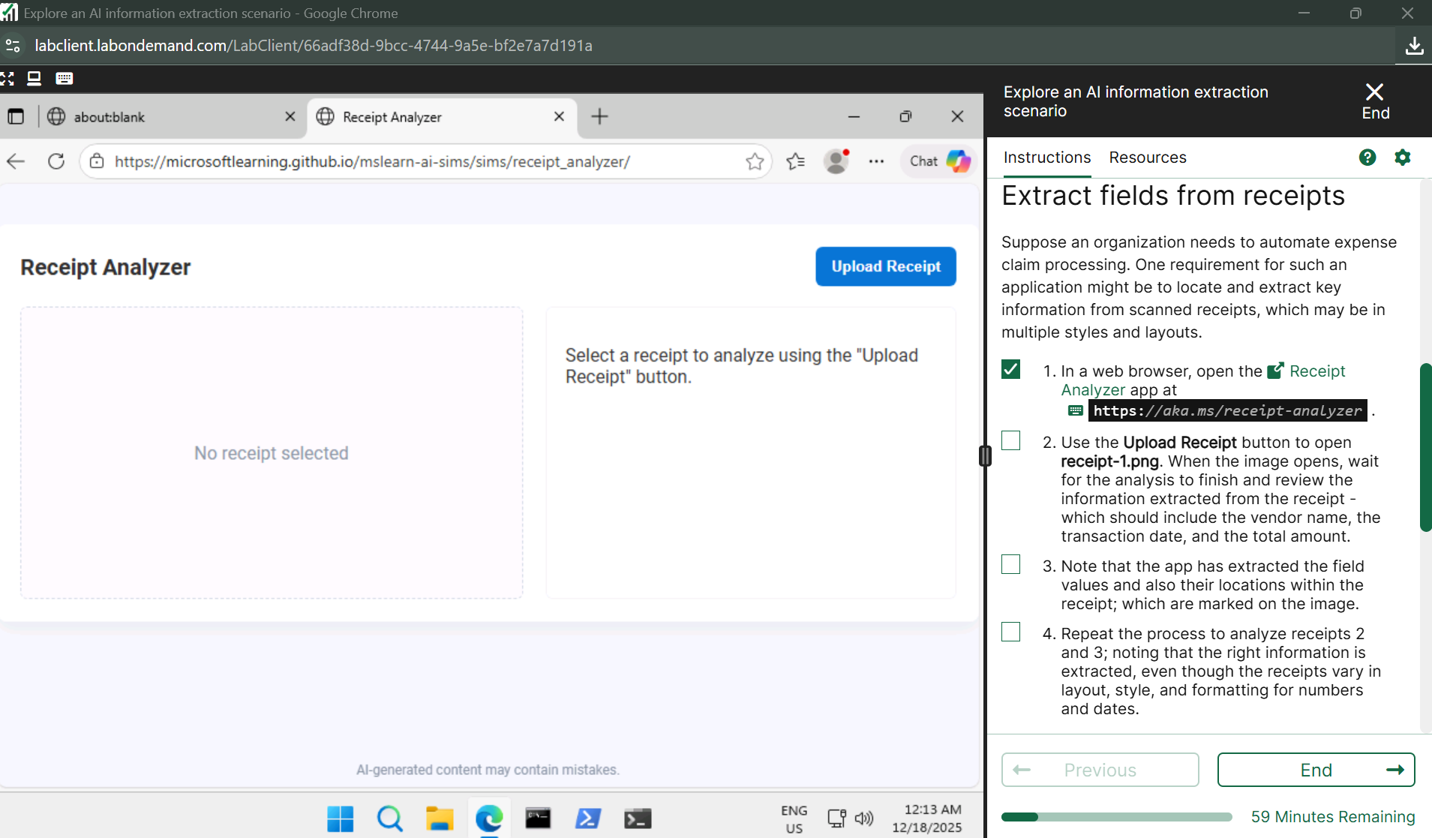

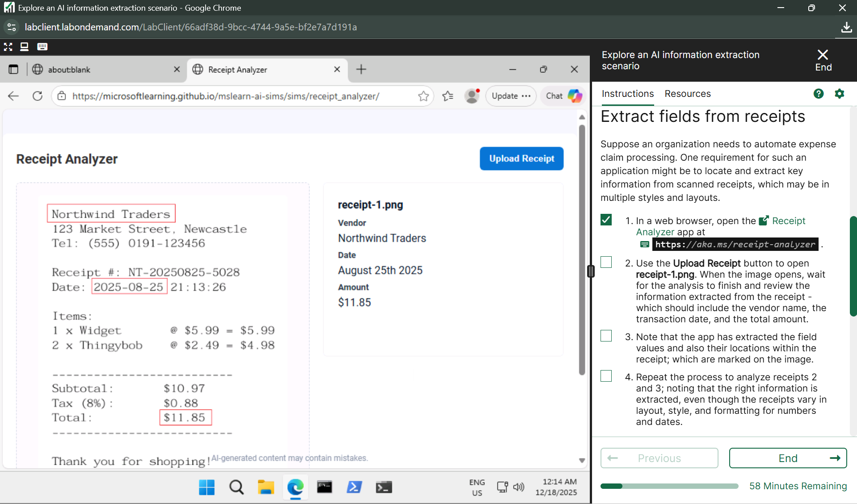

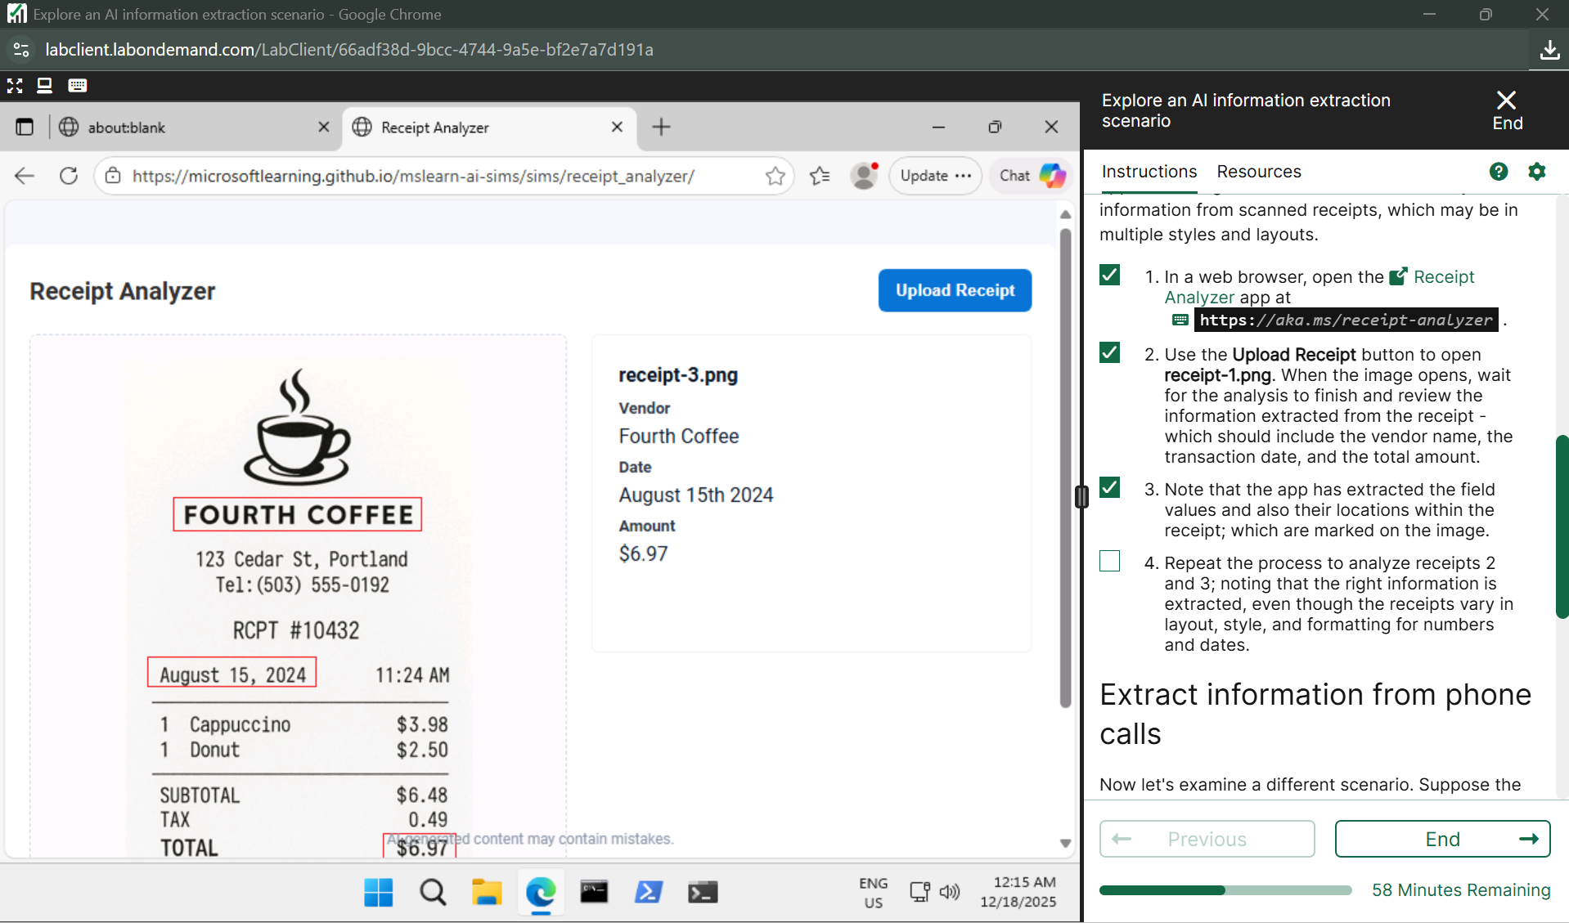

**Voicemail Analyzer**

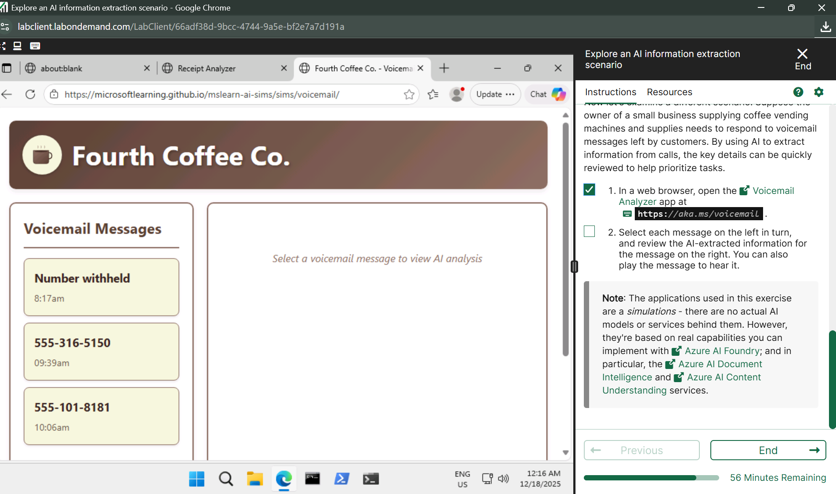

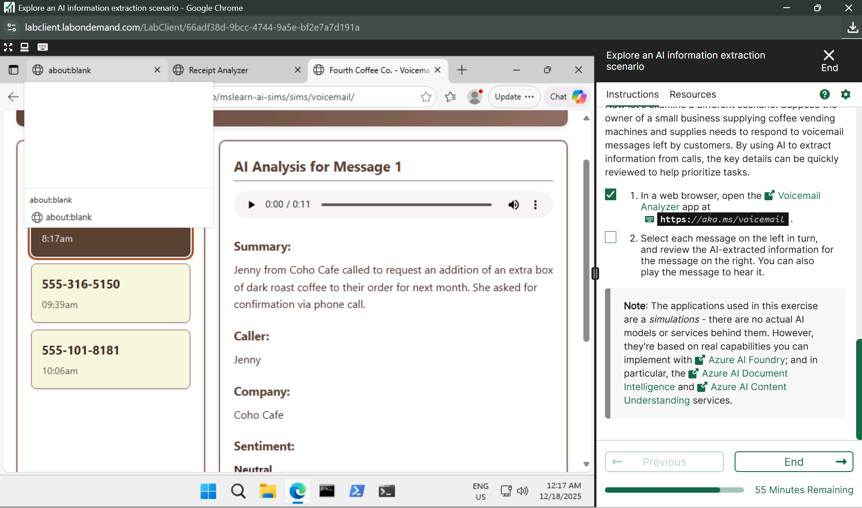

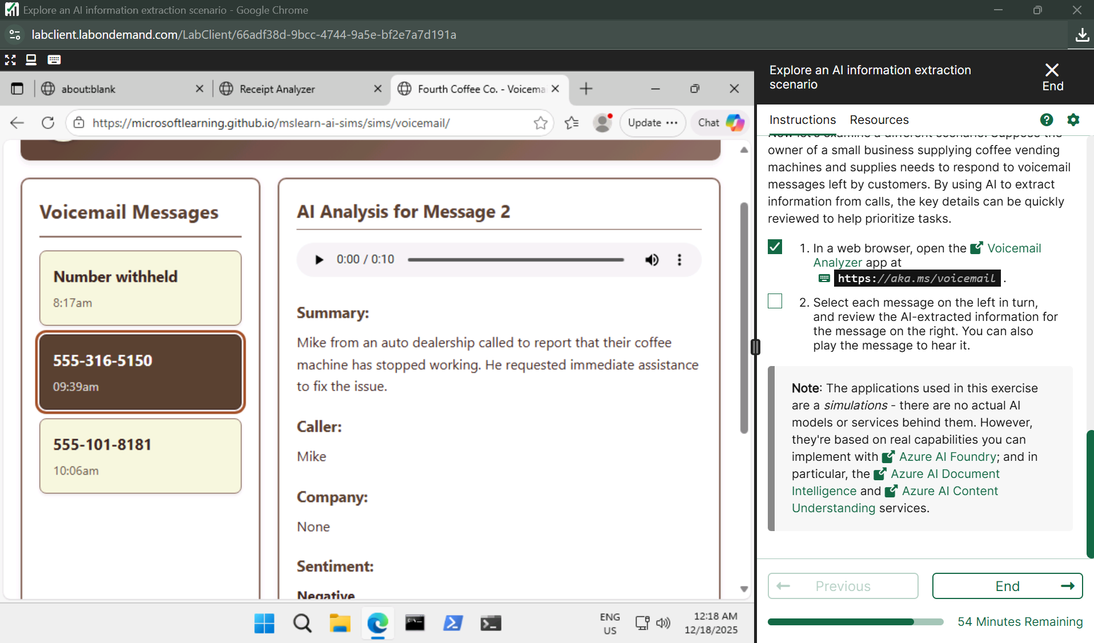

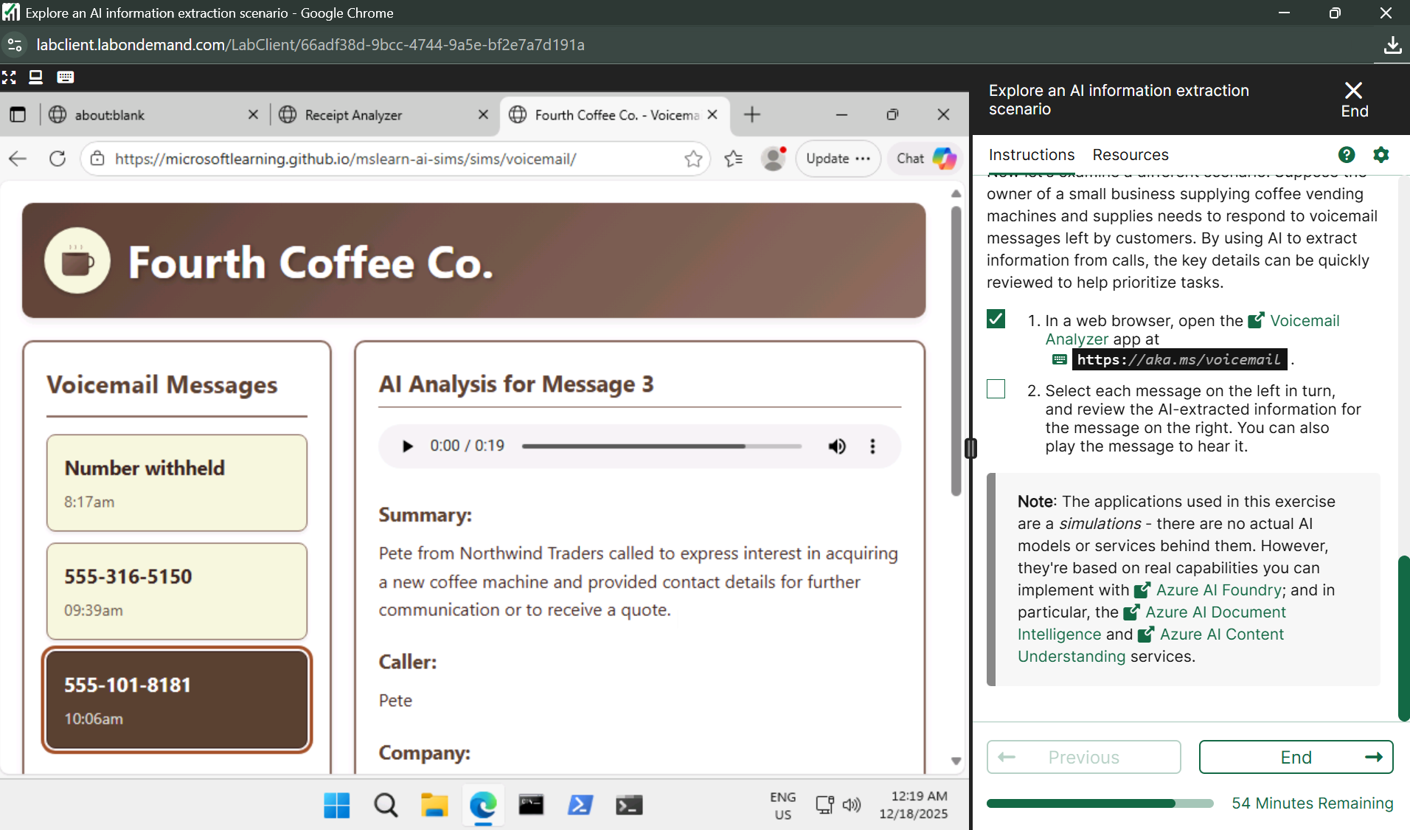

**Lab 11** [**Extract data with Content Understanding in Azure AI Foundry portal​**](https://msle.learnondemand.net/Lab/77499?instructionSetLang=en&classId=720986)

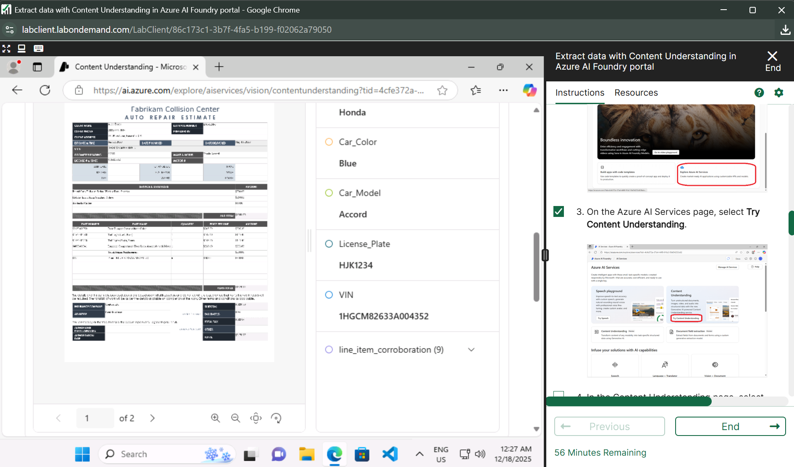

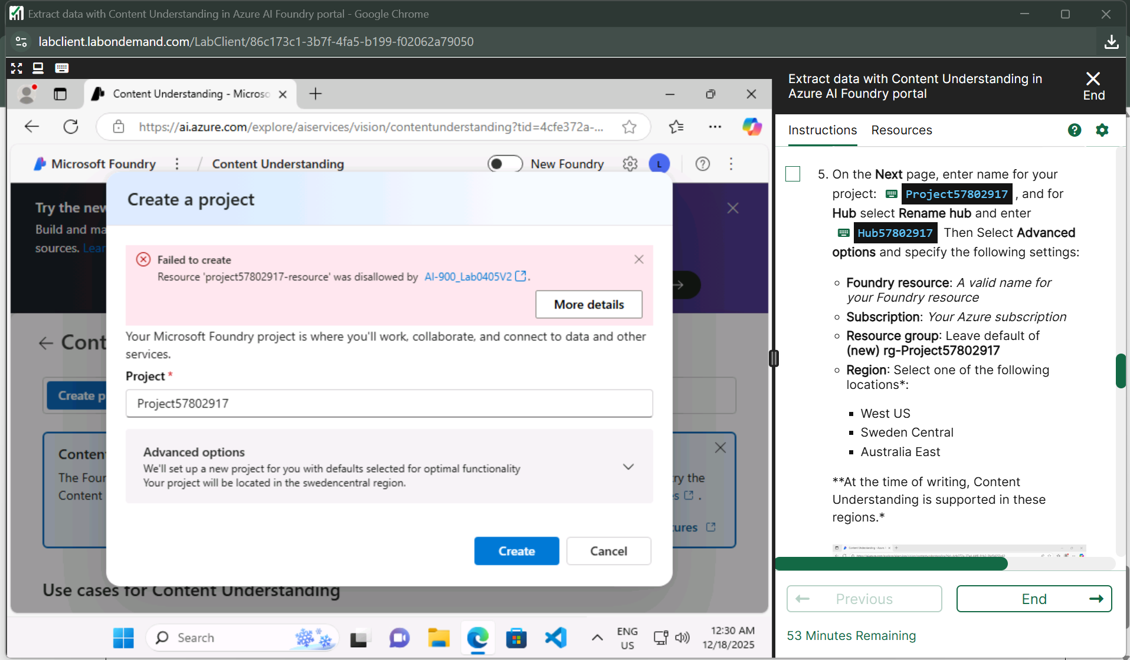**FOR LAB 11 NEED AZ SUBSCRIPTION**